**Features**

**Team 3**

**Drew, Erik, Delvis, Robert**

**Retrieving events from our database**

On the bottom of the homepage of our website, we want to display the next upcoming event that is going to take place for the CS Club. Another place we want to display events is inside our calendar on the events page. We would like to have the event be displayed inside of the date box in our calendar. This feature will be continually worked on by Drew and Erik.

**Admin functionality**

With the permission of an admin, we would like to have them be able to modify most of the content that is displayed on all of the pages. We would like them to also be able to manage all other user accounts, excluding admins. As an admin, we also want them to have the ability to add, update and delete events of the CS Club. This feature will be continually worked on as a group.

**Account profile page**

As a member signs up, they will enter information about themselves and we will take that information and store it in our database. We would like to create another page that will take the data that is respective to that user and display it on another page called ‘account’.This feature will mainly be worked on by Robbie but, the rest of the group will pitch in to help.

**Password reset**

Obviously when a user signs up you will have to enter a username and a password. It is very common thing to forget such password and they will want to reset it. We would like to add some sort of a password reset feature that would allow users to change their password. We have not decided if it is going to be via email or another webpage. This feature is still in the works and we will need to continually talk about it as a group.

**Current SiteMap (As generated by** [**https://www.xml-sitemaps.com**](https://www.xml-sitemaps.com)**)**

<urlset xmlns="http://www.sitemaps.org/schemas/sitemap/0.9" xmlns:xsi="http://www.w3.org/2001/XMLSchema-instance" xsi:schemaLocation="http://www.sitemaps.org/schemas/sitemap/0.9 http://www.sitemaps.org/schemas/sitemap/0.9/sitemap.xsd">

<!--

created with Free Online Sitemap Generator www.xml-sitemaps.com

-->

<url>

<loc>http://webdev.cs.uwosh.edu/students/czosea72/site/</loc>

<lastmod>2018-11-09T11:57:10+00:00</lastmod>

<priority>1.00</priority>

</url>

<url>

<loc>

http://webdev.cs.uwosh.edu/students/czosea72/site/index.php

</loc>

<lastmod>2018-11-09T11:57:10+00:00</lastmod>

<priority>0.80</priority>

</url>

<url>

<loc>

http://webdev.cs.uwosh.edu/students/czosea72/site/aboutUsPage/

</loc>

<lastmod>2018-11-09T11:57:10+00:00</lastmod>

<priority>0.80</priority>

</url>

<url>

<loc>

http://webdev.cs.uwosh.edu/students/czosea72/site/eventsPage/

</loc>

<lastmod>2018-11-09T11:57:10+00:00</lastmod>

<priority>0.80</priority>

</url>

<url>

<loc>

http://webdev.cs.uwosh.edu/students/czosea72/site/accountPage/

</loc>

<lastmod>2018-11-09T11:57:10+00:00</lastmod>

<priority>0.80</priority>

</url>

<url>

<loc>

http://webdev.cs.uwosh.edu/students/czosea72/site/signupPage/

</loc>

<lastmod>2018-11-09T11:57:10+00:00</lastmod>

<priority>0.80</priority>

</url>

<url>

<loc>

http://webdev.cs.uwosh.edu/students/czosea72/site/aboutUsPage/index.php

</loc>

<lastmod>2018-11-09T11:57:10+00:00</lastmod>

<priority>0.64</priority>

</url>

<url>

<loc>

http://webdev.cs.uwosh.edu/students/czosea72/site/eventsPage/index.php

</loc>

<lastmod>2018-11-09T11:57:10+00:00</lastmod>

<priority>0.64</priority>

</url>

<url>

<loc>

http://webdev.cs.uwosh.edu/students/czosea72/site/accountPage/index.php

</loc>

<lastmod>2018-11-09T11:57:10+00:00</lastmod>

<priority>0.64</priority>

</url>

<url>

<loc>

http://webdev.cs.uwosh.edu/students/czosea72/site/signupPage/index.php

</loc>

<lastmod>2018-11-09T11:57:10+00:00</lastmod>

<priority>0.64</priority>

</url>

</urlset>

**Screen Shots**

Home Page: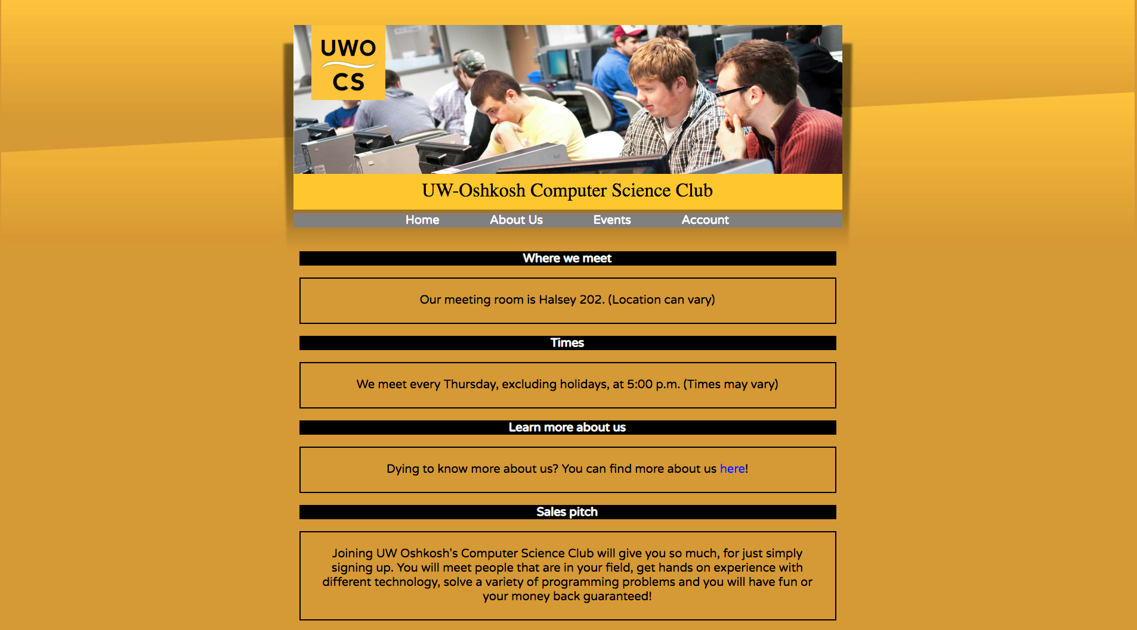About Us Page:

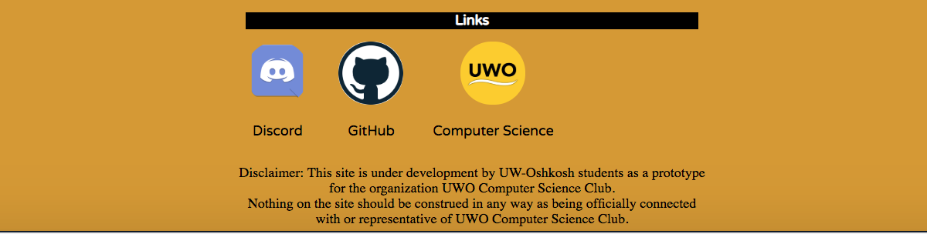

Event Page: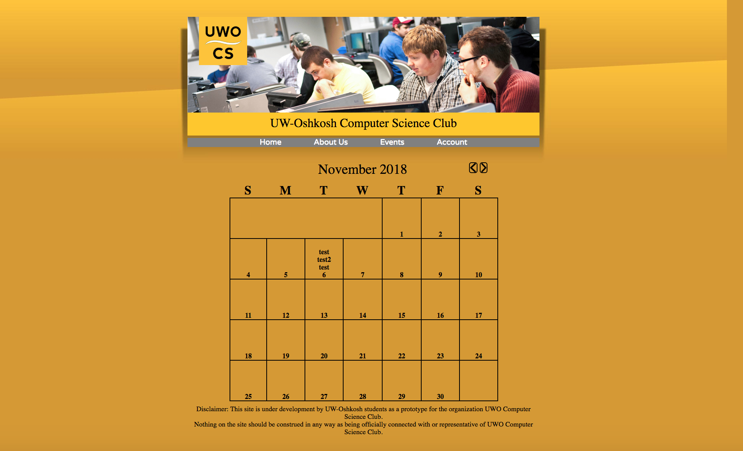

Account Page:

